After analyzing each feature and it’s effect on ticket value, we decided on a random forest regression model, which had a lower mean absolute error of 9.54 compared to 11.79. The random forest model also had a lower degree of variability (standard deviation of mean absolute error). Both models provided evidence that the most important factors behind driving ticket variable are:

1. 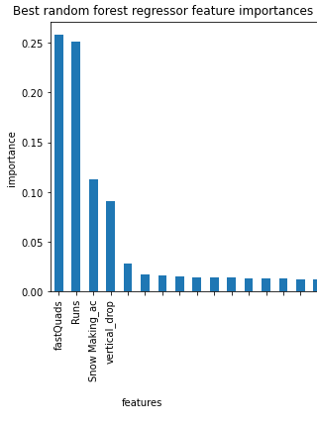Fast quad lifts
2. Runs
3. Snow Making area
4. Total vertical drop

This selected model estimates that the current price of tickets at Big Mountain is lower than the true ticket value by at least $4.48. We were also able to model several possible actions currently being considered to increase ticket value. We found that closing a single run would have little to no impact on ticket value. However, closing more would drop the value by up to $1.75. Opening a new run that raises the vertical drop by 150 ft would increase ticket price by more than that, $1.99. This would lead to an estimated $3,474,638 profit over the course of the season. In either case, increasing the snow making area and longest run by feasible amounts had no impact on ticket price. Therefore these options should be disregarded.